Academic Year: 2025-26 | Year: Second Year | Semester: II
PRN No.: 1012411011 | Name: Riddhee Kulkarni
Subject: Python Programming
Assignment No.: 11
Date: 12/01/2026

Lab Assignment: 11
Aim:
Write a program using loop to read the numbers until -1 is encountered. also count the number of prime numbers and composite numbers entered by the user.

Objective:
- To use a while loop for continuous input.
- To identify prime and composite numbers.
- To apply looping and conditional statements in Python.
- To terminate the loop using a sentinel value (-1).

Theory:
A loop in Python is used to execute a block of code repeatedly. The while loop runs as long as the given condition is true.
A prime number is a number greater than 1 having exactly two factors: 1 and itself.
A composite number is a number greater than 1 having more than two factors.
In this program, the user enters numbers continuously until -1 is entered. Each number is checked for prime or composite and the respective count is increased.

Algorithm:
- Start
- Initialize prime_count = 0 and composite_count = 0
- Read a number from the user
- If the number is -1, stop the loop
- If the number is less than or equal to 1, skip it
- Count the number of factors of the number
- If the number has exactly two factors, increment prime_count
- Otherwise, increment composite_count
- Repeat steps 3 to 8
- Display the prime and composite counts
- Stop

Pseudo Code:
START
prime_count = 0
composite_count = 0
WHILE True
READ n
IF n == -1
BREAK
IF n <= 1
CONTINUE
count = 0
FOR i = 1 TO n
IF n % i == 0
count = count + 1
END FOR
IF count == 2
prime_count = prime_count + 1
ELSE
composite_count = composite_count + 1
END WHILE
PRINT prime_count, composite_count
STOP

Code:
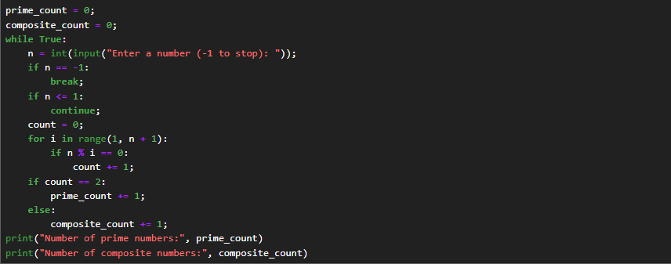

Output:
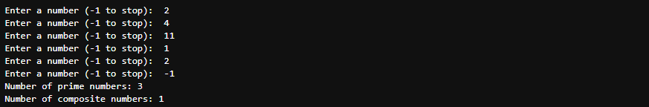

Conclusion:
The program successfully reads numbers until -1 is encountered and correctly counts the number of prime and composite numbers using loops and conditional statements.

